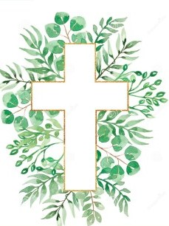
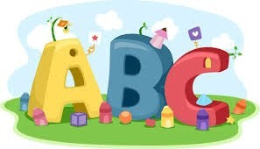
This week in Reception we are learning… W.B. 19.10.26

RE/RSE/PSHE  - This week we will think about how we are all a part of the Church family.  - We will learn about Baptism.  . | Literacy  - In phonics we will learn the sounds and rhymes for the letters j, v, y, w  - We will practice forming the letters  - We will build words using the sounds we have learnt so far.  - We will make a name train.  - We will use our ‘Fred fingers’ to identify the sounds in CVC words.  - Recognising and writing our names.
Mathematics  - We will sing a range of number rhymes and songs.  - We will focus on counting sets and recording how many are in each set.  - We roll a dice and add the correct amount of toppings to a pizza template.  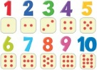  - We will add the correct amount of pegs to a number plate.  - We will collect a given amount of objects in our outdoor area. | Understanding the World    - October is Black History Month- we will learn about Mae Jemison. The children will learn that Mae Jemison was the first black woman to go to space. Children will think about what they would like to do when they grow up.
Physical  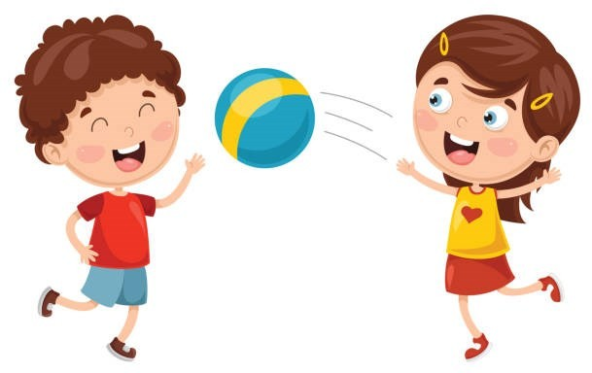  - Construction  - Smile for a Mile  - Dough disco  - Jump start Johnny  - PE with Ross  - Fine motor activities- rescue the conkers from the spider web with tweezers. | Expressive Arts and Design  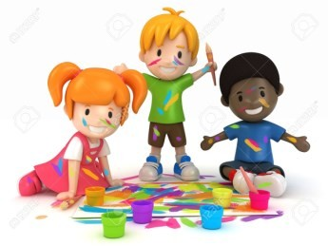  - Leaf art animals  - Junk modelling  - Making an autumn tree using cotton buds and paint to print leaves.

