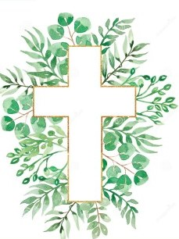
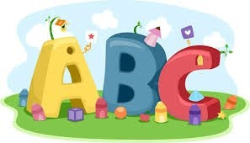
This week in Reception we are learning… W.B. 08.06.26

RE/RSE/PSHE  - We will learn that we are all friends of Jesus.  - We will explore how we can be a good friend.  - We will make cards for our friends.  - We will make friendship bracelets. | Literacy  - In phonics we will learn new sounds and write words and sentences containing theses sounds.  - Our text this week is ‘Beansprout’.  - We will discover a bag of mystery seeds- we will use words to describe the seeds.  - We will choose a seed and draw pictures and write about what we think of seed will grow into.
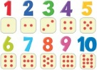  Mathematics  - We will introduce the children to the concept of halving. We will share our magic beans into 2 equal groups.  - We will consolidate our learning about number bonds to 10 through games, such as hide your tower.  - We will play a beanstalk track game to 20 in pairs.  - We will use cubes to measure how tall our flower stems are. | Understanding the World    - We will be planting our own seeds. We will find out all about what a plant needs to grow.  - We will go on a nature colour hunt in our outdoor area.
Physical    - Construction  - Smile for a Mile  - Dough/pen disco  - PE with Ross  - Fine motor activities | Expressive Arts and Design  - Creating our own gardens.  - Father’s day cards.  - Loose part flowers  - Growing curiosity cube.

