Week Beginning: 30th October 2023
This week in Nursery we will be learning…
  Religious Education | - Talking about who is in our family.  - Knowing God gave us our family to love us.
Communication & Language &    Literacy | - Metal Mike – feeding our robot different sounds.  - Making silly soup with rhyming words.  - Playing Eye Spy to hear which sounds words begin with.  - Playing instruments when we hear the sound that our name begins with.  - Talking about the character, setting, problem and solution after hearing a story.  - Exploring our magic story box to see what our new story of the half term is.
Mathematics & Physical development  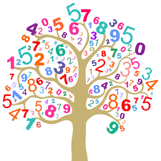 | - Simple number songs to 5.  - Smile for a mile!  - Squiggle while you wriggle!  - Fine motor picking up spiders with tweezers and counting them.  - Fine motor skills with peg boards making patterns.
Other Areas  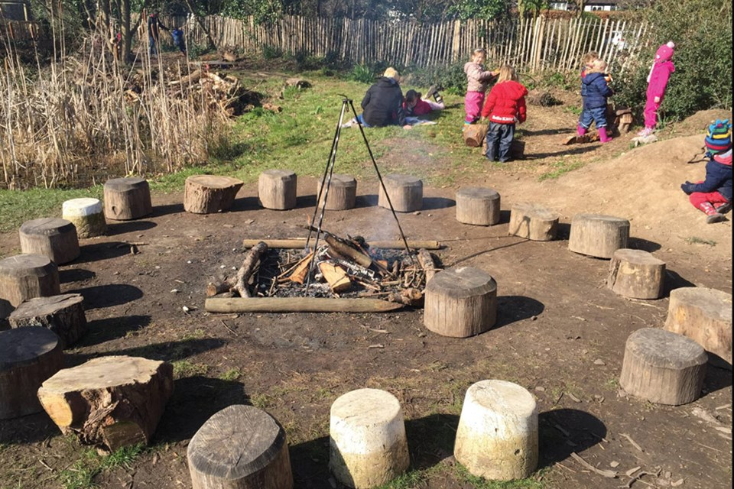 | - Assembly with Mrs Glynn.  - Music on Wednesday.  - Forest School!  - Following a map that we have made to find the rocks that we painted and hid before half term.

