Week Beginning: 2ND October 2023
This week in Nursery we will be learning…
  Religious Education | - Looking at the animals that God made.  - Painting our favourite animal.
Communication & Language &    Literacy | - Going on a walk to find items that begin with a certain sound e.g. ‘b’ we may find a ball, bear, bike, etc.  - Song swap! Children to invent new words to a well known rhyme e.g. baa baa green dinosaur etc.  - Match the sound – children will will have an instrument each. Teacher to play an instrument inside the bag. Chn can only play their instrument if they match the sound.  - Re-telling the story of the colour monster and talking about our feelings, in particular how to calm ourselves.
Mathematics & Physical development  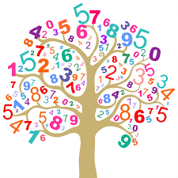 | - Simple number songs to 5.  - Smile for a mile!  - Squiggle while you wriggle!  - Dough disco.  - Using movement to explore feelings of fear and love.  - Making a repeated pattern with numicon and paint.
Other Areas  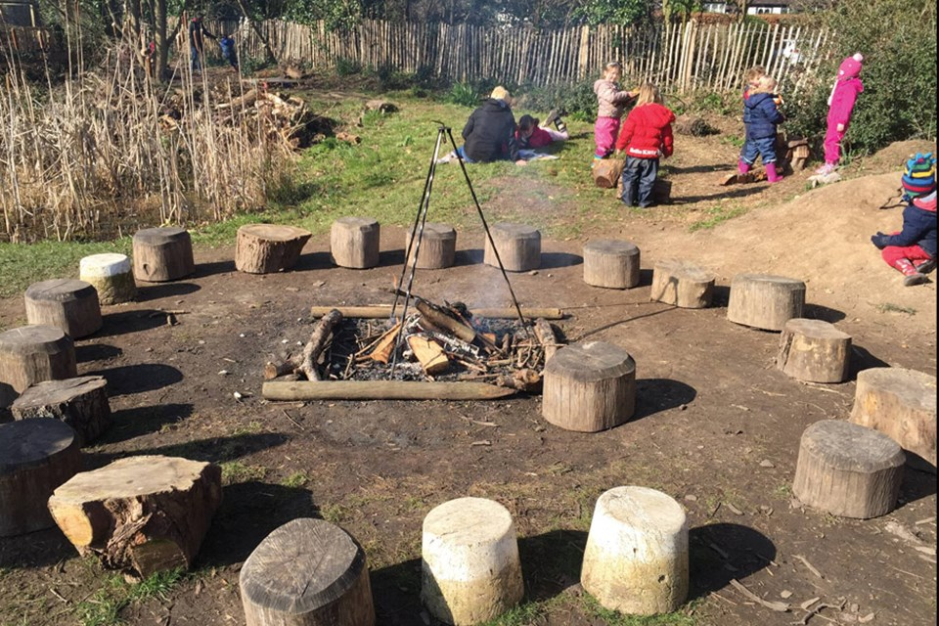 | - Name games to get to know our new friends.  - Circle times about our first day at nursery compared to now.  - Assembly with Mrs Glynn.  - Music on Wednesday.

