Week Beginning: 18th September 2023
This week in Nursery we will be learning…
  Religious Education | - About our special book called the bible.  - Re-capping what we can remember about the story of creation.
Communication & Language &    Literacy | - Going on a listening walk to hear environmental sounds.  - Exploring musical instruments, what they are called and how we can change the speed and volume as we play.  - Who is it? A child will be given a musical instrument and the other children will guess who has it based on where they heard the sound go.  - Listening to rhyming stories.  - Re-telling the story of the colour monster and talking about our own feelings.
Numeracy & Physical development  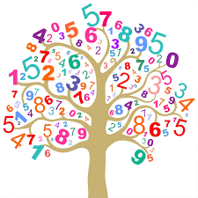 | - Simple number songs to 5.  - Smile for a mile!  - Practicing cutting skills.  - Using movement to explore feelings of happy and sad.
Other Areas  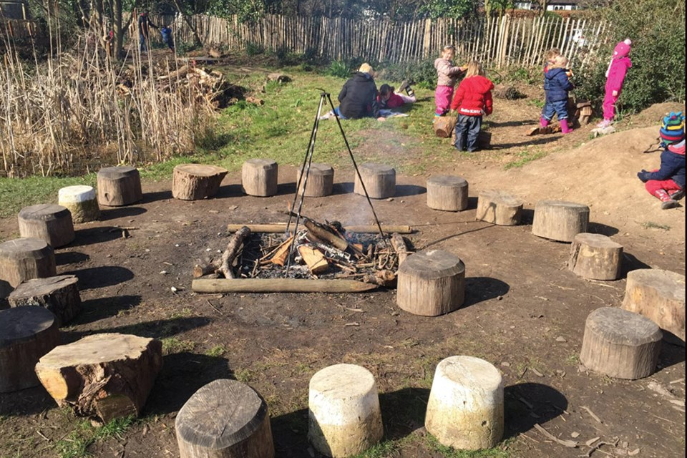 | - Outdoor play.  - Name games to get to know our new friends.  - Circle times about our golden rules.  - Assembly with Mrs Glynn.  - Music with Mrs Marshall.

