Week Beginning: 30th June 2025
This week in Nursery we will be learning…

  Religious Education | - Talking about People who help us and how we need to look after the people that God has made.
Communication & Language &    Literacy | - Name Writing  - Eye spy, recognising the initial sounds in words.  - ‘i’ sound.  - Reading the story of ‘What the ladybird heard’.  - Drawing the setting from our story.
Mathematics & Physical development   | - Smile for a mile!  - Squiggle while you wriggle!  - Bingo.  - Cutting skills.  - Thinking about capacity, which containers will hold the most and the least.
Other Areas  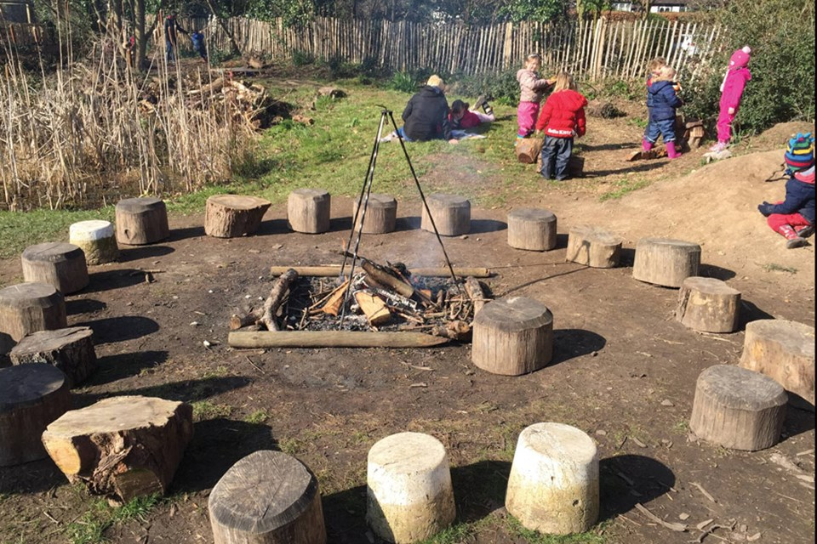 | - Assembly with Mrs Glynn.  - SPORTS DAY on Monday.  - FOREST SCHOOL on Friday.  - Talking about our Euros country which is Wales.

