Week Beginning: 19th June 2025
This week in Nursery we will be learning…

  Religious Education | - Know we all belong to God’s family and to reflect on what this means for us.  - Talking about our own families.
Communication & Language &    Literacy | - Name Writing  - Eye spy, recognising the initial sounds in words.  - Reading the story of ‘What the ladybird heard’.
Mathematics & Physical development  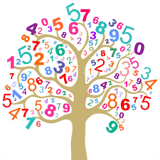 | - Smile for a mile!  - Squiggle while you wriggle!  - Bingo.  - MOTD – Finding different ways to make one, two, three, four and five.  - Knowing one more than a given number.
Other Areas  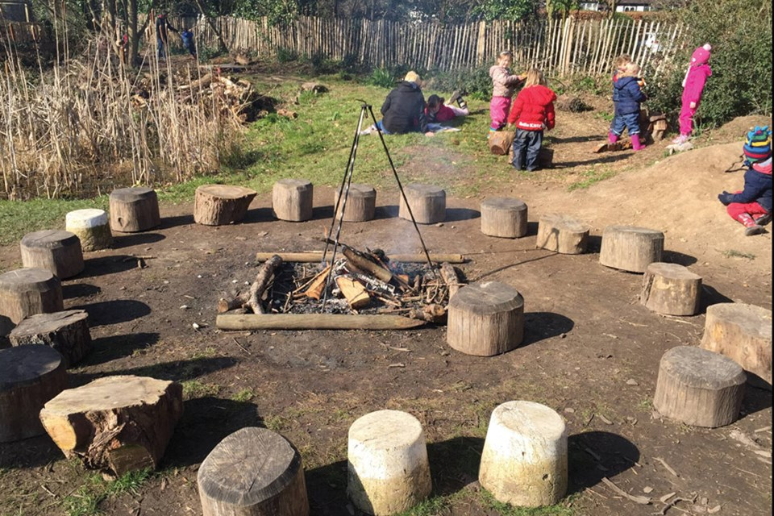 | - Assembly with Mrs Glynn.  - Music on Wednesday.  - Forest school on Friday.  - Making fathers day cards.

