Week Beginning: 12th May 2025
This week in Nursery we will be learning…

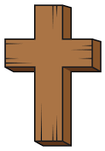  Religious Education | - Talking about how May is the month for Mary.
Communication & Language &    Literacy | - Name Writing  - Children to blend together three sounds to make a word E.g. p-i-g.  - ‘a’ sound.  - Talking about different farm animals and naming baby farm animals.
Mathematics & Physical development  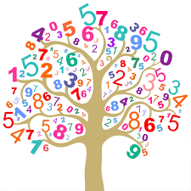 | - Smile for a mile!  - Squiggle while you wriggle!  - Dough disco.  - Number songs.  - Knowing numbers that are one less than e.g. one less than three is two.  - Recognising numbers to 10.
Other Areas  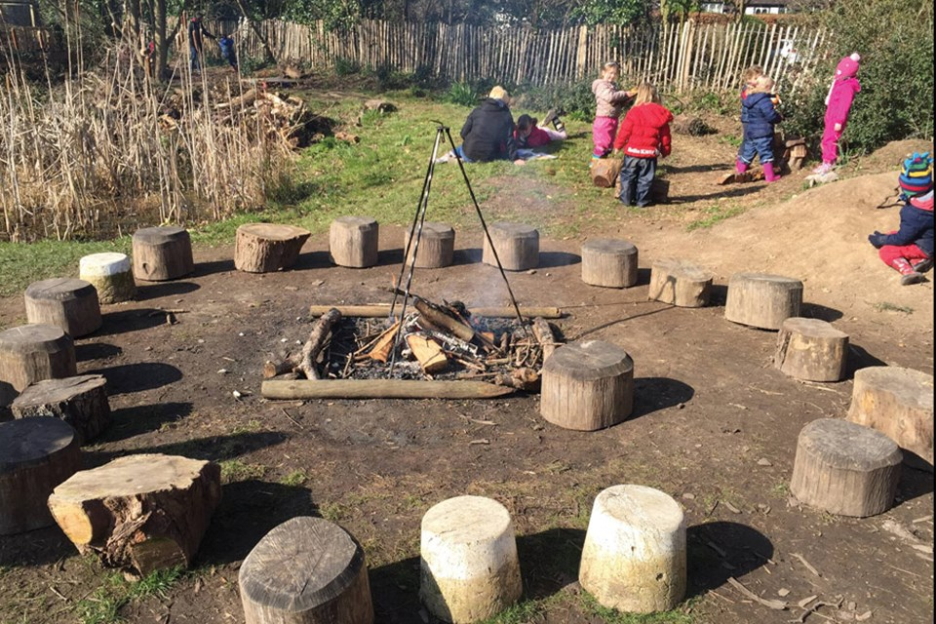 | - Assembly with Mrs Glynn.  - Our eggs will be arriving ready to hatch!  - Forest School on Friday.

