Week Beginning: 22nd April 2024
This week in Nursery we will be learning…

  Religious Education | - To hear about how Jesus chose his disciples.
Communication & Language &    Literacy | - Name Writing  - Eye spy — Children to identify initial sounds in words.  - Whats in the box?—children get a clue and the initial sound to guess what animal is hiding in the box e.g. it lives on the farm and begins with ‘p’.  - ‘i’ sound.
Mathematics & Physical development  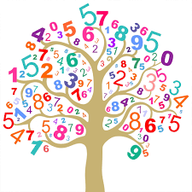 | - Smile for a mile!  - Squiggle while you wriggle!  - Mark making, finding different ways to show numbers to 5.  - Recognising numbers to 10.
Other Areas  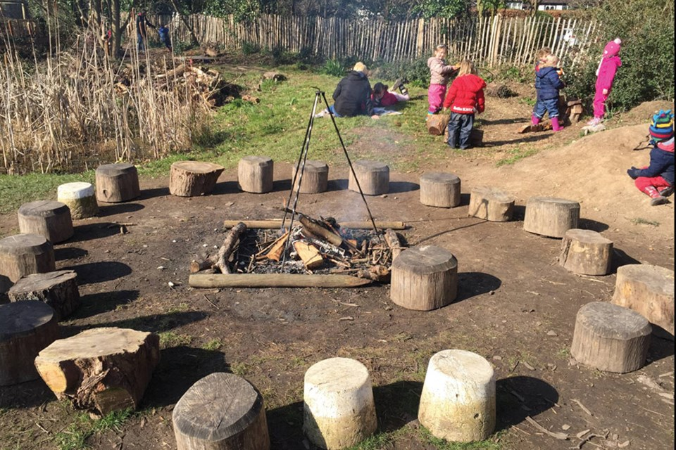 | - Assembly with Mrs Glynn.  - Music on Wednesday.  - Naming farm animals and their babies ready for our trip next Tuesday!  - Using junk modelling materials to make farm animals.  - Forest school on Tuesday and Friday (spare clothes needed on Friday only)

