Week Beginning: 18th March 2024
This week in Nursery we will be learning…

  Religious Education | - The Story of ‘Jesus and the Fishermen.’  - Talking about how Jesus was a good role model, thinking of ways in which we can be good role models.
Communication & Language &    Literacy | - Re-telling the story of Jack and the Beanstalk.  - Metal mike— Children to blend together three sounds to make a word. This will relate to an object that they will then feed the robot. E.g. p-i-g.  - Silly soup— Children to mix rhyming words into the soup bowl.  - ‘d’ sound.
Mathematics & Physical development   | - Smile for a mile!  - Squiggle while you wriggle!  - Making a beanstalk from playdoh.  - Independently finding different ways to show 1,2,3 and 4 e.g. with numicon, with blocks, with dice etc.  - Balancing on a number of different parts of the body e.g. balance of three parts could be two hands and one foot.
Other Areas  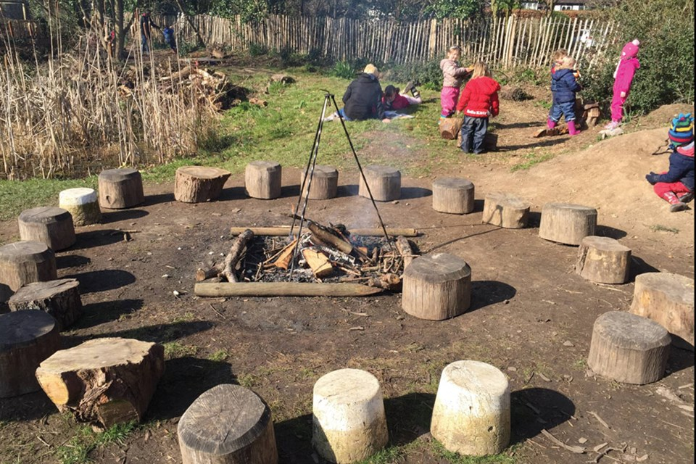 | - Assembly with Mrs Glynn.  - Music on Wednesday.  - Decorating Easter eggs.  - Forest school visits. N1 Tuesday and N2 &FT Friday. (change of clothes Friday only)  - Parents Evenings on Tuesday or Thursday.

