Week Beginning: 4th March 2024
This week in Nursery we will be learning…

  Religious Education | - Talking about what our Mum’s do for us and why we are thankful of this.  - Mothers Day crafts.
Communication & Language &    Literacy | - Re-telling the story of the three little pigs.  - World Book Day Activities! Such as visiting the reading café, mystery readers drop everything and read, building reading dens outdoors.  - Eye Spy— Children to identify objects by initial sound. Eye spy with my little eye something beginning with…….  - Silly soup— Children to mix rhyming words into the soup bowl.  - ‘m’ sound.
Mathematics & Physical development  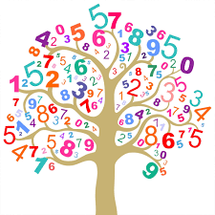 | - Smile for a mile!  - Squiggle while you wriggle!  - Cutting Skills.  - We will be finding different ways to show the number five.  - Matching the correct amounts of objects to numerals 0-5.  - Showing different amounts on five frames.
Other Areas  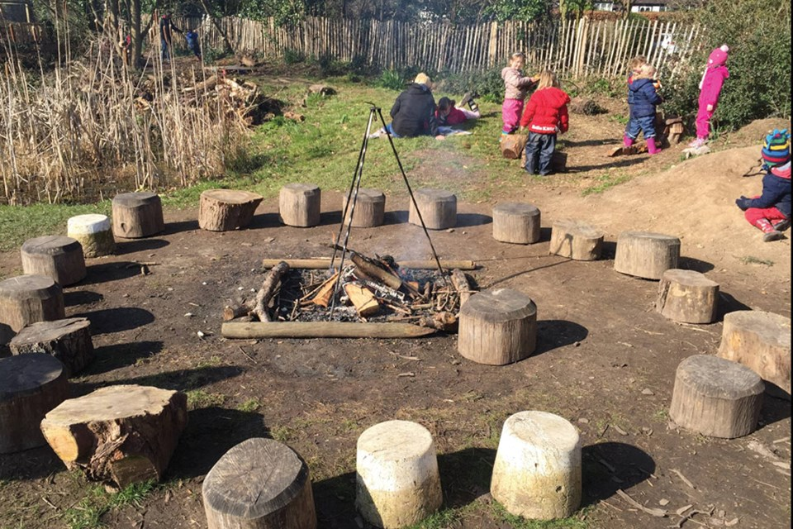 | - Assembly with Mrs Glynn.  - Music on Wednesday.  - PE in the hall. This half term we are doing gymnastics so will be looking at balancing on different parts of our body.  - Forest School on Tuesday and Friday.  (Spare clothes needed for Friday only)

