Week Beginning: 26th January 2024
This week in Nursery we will be learning…

  Religious Education | - Talking about Lent and what this means.  - Making a class Lenten promise.
Communication & Language &    Literacy | - Recording the story of the three little pigs as a story map.  - Activity: Sounds Like— Children will find an object from the middle of the circle. They will put it in the hoop with objects that begin with the same sound.  - Shopping bag— Playing I went to the shop and I bought… Each child will select an object and put it into the bag, sounding it out. They will re-call the objects of all of the children who have been ‘shopping’ before them.  - ‘s’ sound.
Mathematics & Physical development  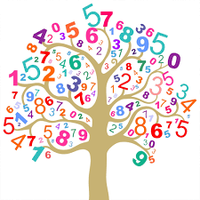 | - Smile for a mile!  - Squiggle while you wriggle!  - Cutting Skills.  - We will be finding different ways to show the number four.  - Naming and sorting 2D shapes.
Other Areas  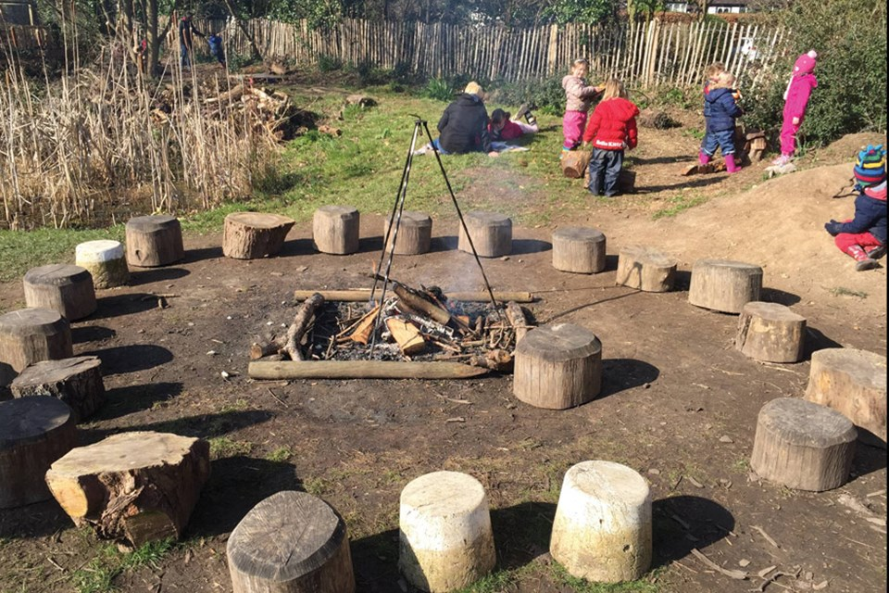 | - Assembly with Mrs Glynn.  - Music on Wednesday.  - PE in the hall. This half term we are doing gymnastics so will be looking at balancing on different parts of our body.

