Week Beginning: 29th January 2024
This week in Nursery we will be learning…
Our Nursery Rhyme of the Week is Miss Polly Had a Dolly
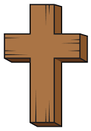  Religious Education | - Talking about how we can show our love for others.  - Celebrating our differences.
Communication & Language &    Literacy | - Singing Nursery rhymes.  - Choo Choo—We have a large train with 3 parts, front, middle and end. Children will blend the sounds they hear to choose an item to put in different parts of the train.  - Odd one out— There will be a number of rhyming items and one that doesn't rhyme. Children will work as a team to find the odd one out.  - Roly Poly— We will sing a rhyme with actions and change our voice sounds to the rhyme to be faster/slower and louder/quieter.  - We will write a card for Miss Polly’s Dolly and sign it with our name.
Mathematics & Physical development  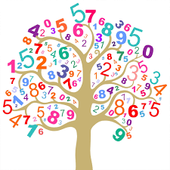 | - Smile for a mile!  - Squiggle while you wriggle!  - Cutting Skills.  - MOTD— numerals 1-3 in hoops. Children to run around and put the correct number of beanbags in each hoop.  - Number songs e.g. 5 current buns in a bakers shop, 5 little men in a flying saucer etc.  - Sorting by colour and numeral.  - PE in the hall creating a nursery rhyme dance.  (reminder PE kits in nursery are only requested on Friday forest school days.)
Other Areas  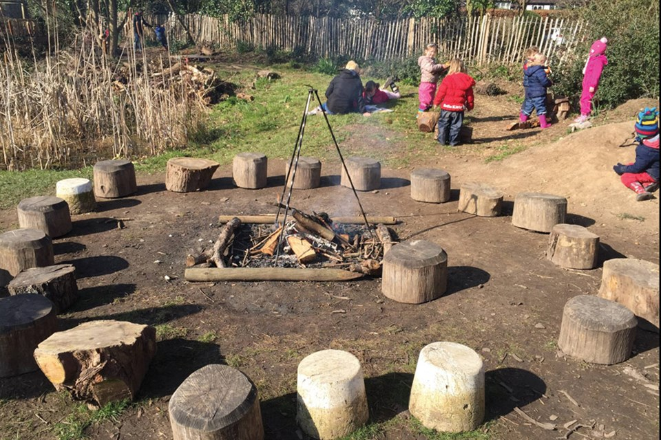 | - Assembly with Mrs Glynn.  - Music on Wednesday.  - Forest School on Tuesday and Friday (spare clothes on Friday only)

