Week Beginning: 22nd January 2024
This week in Nursery we will be learning…
Our Nursery Rhyme of the Week is 5 little speckled frogs.
  Religious Education | - Talking about how Jesus loves little children.  - Knowing what makes each of us unique and special.
Communication & Language &    Literacy | - Singing Nursery rhymes.  - Activity: Treasure Hunt—Pictures will be spread around the room. Children work in pairs to find a pair that rhyme.  - Cross the river— children all have an object and can jump over the river when they hear their word in Fred talk e.g. p-i-g.  - What’s in the box— teacher to sound out CVC word. Children guess what is hiding in the box.  - Visit to the school library to choose a new book to take home and to listen to stories.
Mathematics & Physical development   | - Smile for a mile!  - Squiggle while you wriggle!  - Cutting Skills.  - MOTD—finding and naming 2D shapes.  - Number songs e.g. 5 current buns in a bakers shop, 5 little men in a flying saucer etc.  - Finding different ways to show 3.  - Sorting frogs on lily pads – putting the correct amount of frogs on each numeral.  - PE in the hall creating a nursery rhyme dance.  (reminder PE kits in nursery are only requested on Friday forest school days.)
Other Areas  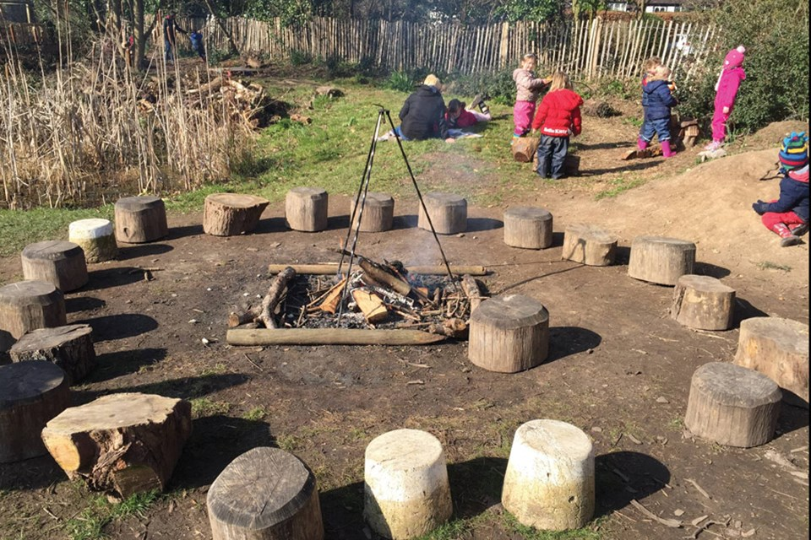 | - Assembly with Mrs Glynn.  - Music on Wednesday.  - Talking about different occupations from our nursery rhymes e.g. the farmer, bus driver, doctor etc.

