Week Beginning: 20th January 2025
This week in Nursery we will be learning…
Our Nursery Rhyme of the Week is Miss Polly’s Dolly
  Religious Education | - Jubilee launch day.  - Making a pledge for our hopes for Gods world.
Communication & Language &    Literacy | - Singing Nursery rhymes.  - Treasure Hunt—. Children work in pairs to find pairs that rhyme that are hidden around the room.  - Syllables— children to take it in turns to say their name and clap the syllables.  - Writing our names in a get well soon card for Miss Polly’s Dolly.
Mathematics & Physical development  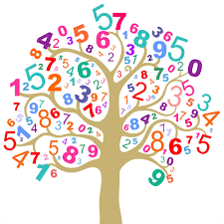 | - Smile for a mile!  - Squiggle while you wriggle!  - Cutting Skills  - Number songs e.g. 5 current buns in a bakers shop, 5 little men in a flying saucer etc.  - Finding different ways to show 3.  - PE in the hall.  - Shape Hunt outside.
Other Areas  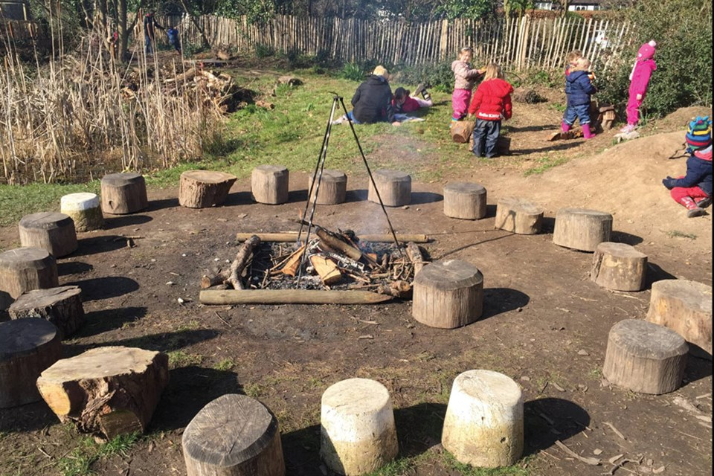 | - Assembly with Mrs Glynn.  - Music on Wednesday.  - Library on Friday.  - Looking at pictures of different occupations from our nursery rhymes and talking about these. E.g. bus driver from wheels on the bus, farmer from Old Macdonald, Nurse/Doctor from Miss Polly. Talk about what their jobs might be, what might they have to do, why is their job important , what job would the children like to do when they are older.

