Week Beginning: 7th September 2024
This week in Nursery we will be learning…
  Religious Education | - Looking at the Rosary for the month of Mary.  - Looking at our new class prayer book.
Communication & Language &  Literacy Development   | We will have our colour monster characters. Each child will have a colour monster sheet. They will try and cut on their monster. They will then colour their monster with their feeling and explain why they have picked that colour.  - Shopping bag—’I went to the shop and I bought…’ but have a bag of objects that all begin with the same sound e.g. pig, pencil, paint, pot, penguin etc. by the end the child will have to remember what everyone else has bought plus their own item.  - Sound lotto—play an animal sound and the children hold up the animal that matches the sound.  - Which sound—play an instrument behind a screen and the children have to guess what is being played.
Numeracy &  Physical Development   | - Simple number songs to 10.  - Smile for a mile!  - Maths of the Day –children given two colours of hoops to make ABABAB patterns in teams e.g. blue, red, blue, red.
Other Areas  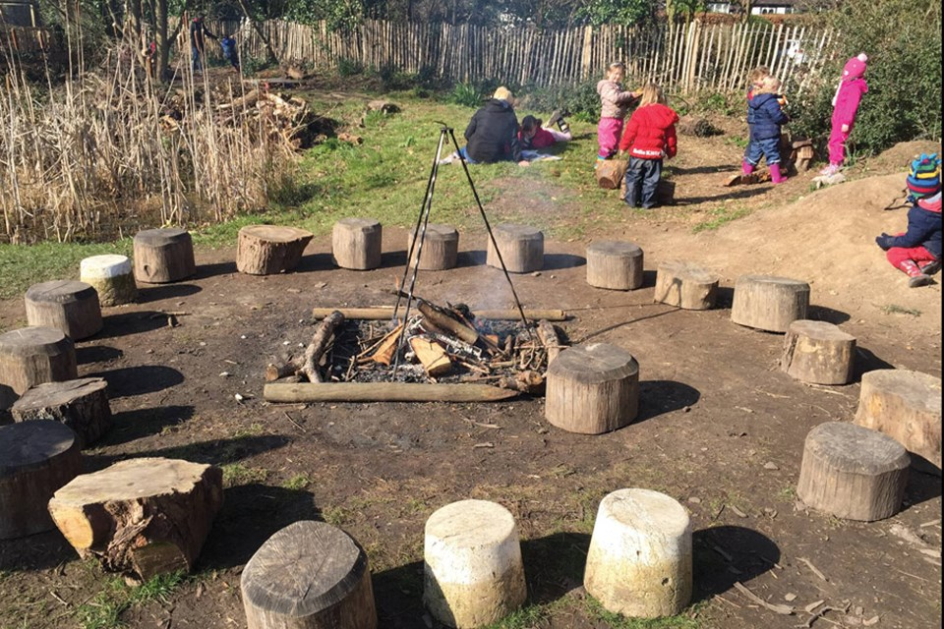 | - Outdoor play  - Learning about our classroom.  - Learning about our Golden Rules.  - Talking about Mo Farrah for Black History Month.

