Week Beginning: 23rd September 2024
This week in Nursery we will be learning…
  Religious Education | - Going to Harvest Assembly.  - RE baseline assessments.
Communication & Language &  Literacy Development   | - Circle Times – getting to know one another.  - We will have our colour monster characters. The children will talk about anger and how we can deal with this e.g. practicing deep breathing, counting to ten etc.  - Listening Walk – Going on a walk around our school to see what we can hear.  - Naming instruments for Speed and Volume—children will practice naming instruments and then follow instructions to play loudly, quietly, fast and slow.  - Drawing our faces and seeing if we can form any letter shapes from our name.
Numeracy &  Physical Development   | - Simple number songs to 10.  - Smile for a mile!  - Maths of the Day – outdoors children will get a coloured hoop and will fill the hoop with things of the correct colour. They will then do this with different colours.  - Sorting toy animals in different ways e.g. by colour, size, type of animal etc.
Other Areas  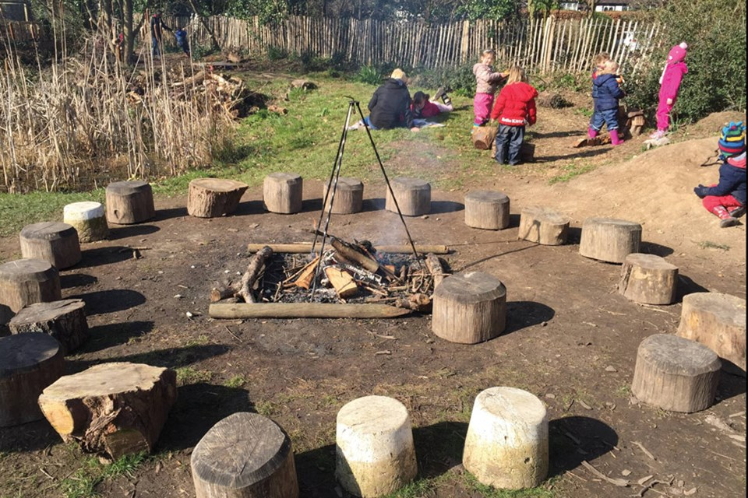 | - Outdoor play  - Learning about our classroom.  - Learning about our Golden Rules.  - Getting to know our new friends.  Parents School Readiness Workshop on Thursday 9am.

