Week Beginning: 16th September 2024
This week in Nursery we will be learning…
  Religious Education | - Reading the story of creation.  - Talking about what a Bible is.
Communication & Language &  Literacy Development   | - Circle Times – getting to know one another.  - We will have our colour monster characters. The children will be asked to show a happy and sad and face. We will then talk about what makes us feel happy and sad.  - Who is it? – One child will sit on a chair with their back to the others. Another child will be given some bells. The volunteer then turns around and guesses who has them based on which direction the sound came from.  - Naming instruments for Speed and Volume—children will practice naming instruments and then follow instructions to play loudly, quietly, fast and slow.  - Musical statues—children will play their instruments and freeze like a statue to make the instrument stop playing.  - Baseline assessments.
Numeracy &  Physical Development   | - Simple number songs to 10.  - Baseline Assessments.  - Smile for a mile!
Other Areas  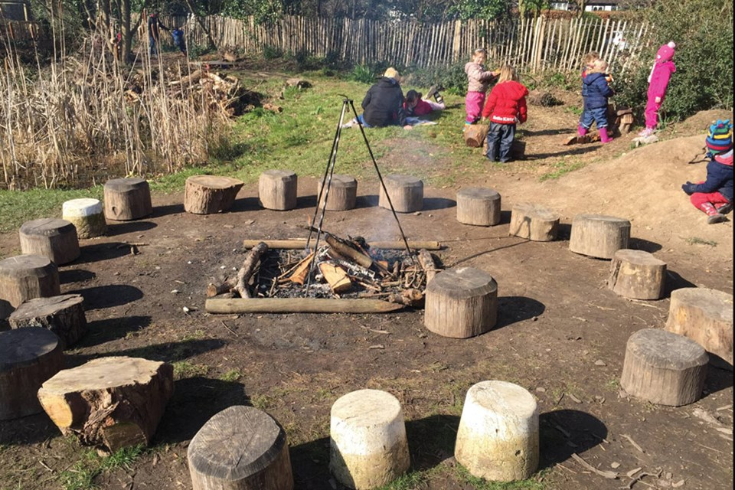 | - Outdoor play  - Learning about our classroom.  - Learning about our Golden Rules.  - Getting to know our new friends.  - Forest School on Friday!

