Week Beginning: 9th September 2024

This week in Nursery we will be learning…

  Religious Education | - God’s wonderful world.  - The story of creation.
Communication & Language &  Literacy Development   | - Circle Times – getting to know one another.  - To speak out in front of a familiar group.  - Baseline assessments.
Numeracy &  Physical Development   | - Simple number songs to 10.  - Baseline Assessments.  - Smile for a mile!
Other Areas  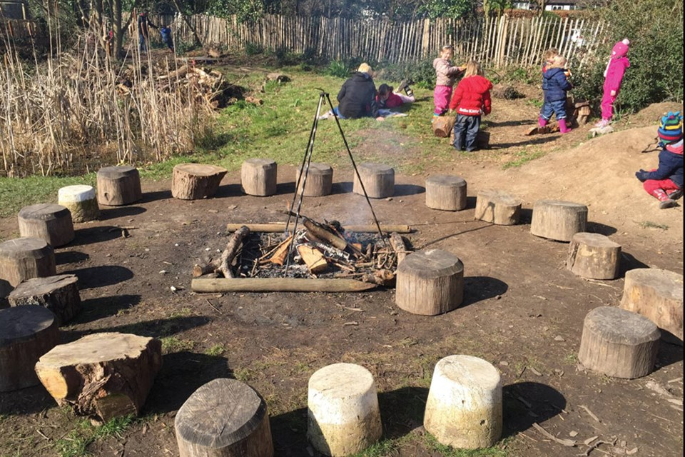 | - Outdoor play  - Learning about our classroom.  - Learning about our Golden Rules.  - Getting to know our new friends.

