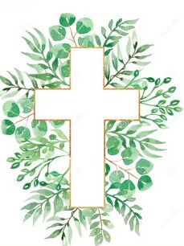
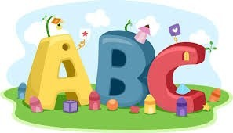
This week in Reception we are learning… W.B. 26.01.26

RE/RSE/PSHE  - We will think about how Jesus helped the poor. We will explore all of the ways we have helped people in need.  - Celebration of the word | Literacy  - In phonics we will learn the special friends ay and ee. We will use our Fred fingers to help us spell words and write simple captions.  - We will play pass the special friend- we will pass around a basket filled with words containing ‘Special friends’ when the basket stops on us, we will take out the picture, ‘Fred talk’ the word and write it.  - We will write simple ‘I can see’ sentences.
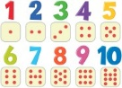  Mathematics  - We will explore the concept of 5 and a bit to make 6 and 7. We will use 2 die frames to compose the numbers 6 and 7. What is the quickest way to show 6? 7?  - We will explore the composition of 6 by throwing 6 beanbags into a hoop. How many landed in the hoop?, How many landed outside the hoop? How many altogether?  - We will explore the composition of 5 using 5 frames and the rhyme ‘5 Little Speckled Frogs’.  - We will explore 3D shapes and their properties by rolling them down ramps. Which ones roll? Why do they roll? Can we build our own 3D shapes?  - We will use timers to explore how many beads we can thread in 1 minute. | Understanding the World    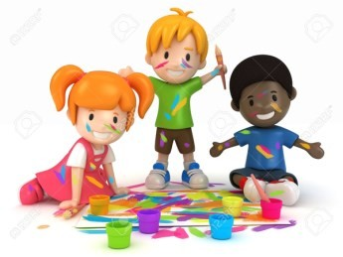  - We will build our own den outside for bird watching. We will use a bird identification sheet to see which birds we can spot in our outdoor area.
Physical    - Construction  - Smile for a Mile  - Dough/pen disco  - Forest school  - PE with Ross  - Fine motor activities | Expressive Arts and Design  - Nursery rhyme stick puppet  - Making our own boats  - Making a playdough mouse  - Designing and building our own clocks.

