
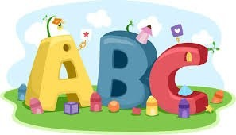
This week in Reception we are learning… W.B. 19.01.26

RE/RSE/PSHE  - Golden box- Holy family- we will think about our families and explore the Holy family.  - Celebration of the word | Literacy  - In phonics we will learn the special friend nk. We will use our Fred fingers to help us spell words and write simple captions.  - We will make story maps for the nursery rhyme ‘Incy Wincy Spider’.  - We will write CVC words.
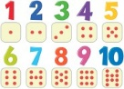  Mathematics  - We will explore the composition of 5, using double sided counters, we will drop the counters onto the table. How many red? How many yellow? How many altogether?  - We will explore the composition of 5 using 5 frames and the rhyme ‘5 Little Speckled Frogs’.  - We will match quantities to amounts by adding peg legs to numbered spiders.  - We will explore 5 or not 5. | Understanding the World    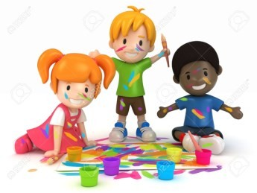  - We will look at the season of Winter. What might we see in Winter? What is the weather like in Winter?  - We will dress our teddies ready for Winter.  - We will look for signs of Winter in the outdoor area.
Physical    - Construction  - Smile for a Mile  - Dough/pen disco  - PE with Ross  - Fine motor activities | Expressive Arts and Design  - Make our own Incy Wincy spider.  - Painting Nursery rhyme characters.

