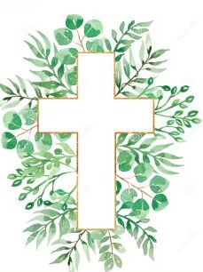
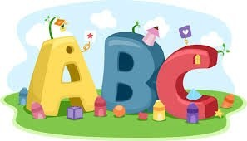
This week in Reception we are learning… W.B. 12.01.26

RE/RSE/PSHE  - Golden box- The Kings followed the star.  - Celebration of the word. | Literacy  - In phonics we will learn the special friend ng. We will use our Fred fingers to help us spell words and write simple captions.  - We will discover a crime scene. Humpty Dumpty has fallen off the wall. What happened to Humpty?  - We will write sentences about what happened to Humpty.  - We will make missing posters for Humpty.
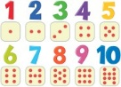  Mathematics  - We will explore one more by building a staircase to 6 using multilink. Can we notice the one more pattern. We will take towers away and ask children to find the missing tower.  - We will play a track game 1-10.  - We will order the numberblocks 1-6 (cut and stick) | Understanding the World    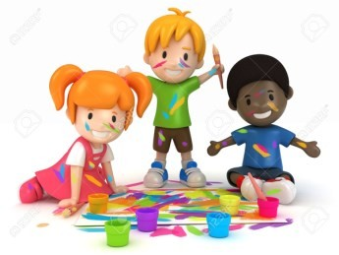  - We will role play doctors linked to Miss Polly had a dolly.
Physical    - Construction  - Smile for a Mile  - Dough/pen disco  - PE with Ross  - Fine motor activities | Expressive Arts and Design  - Painting Nursery rhyme characters.  - Make our own Humpty Dumpty using a potato.

