
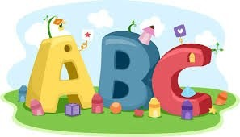
This week in Reception we are learning… W.B. 05.01.26

RE/RSE/PSHE  - Golden box- The Epiphany- What gifts did the Kings bring to Jesus.  - Celebration of the word. | Literacy  - In phonics we will learn the special friend ch and th. We will use our Fred fingers to help us spell words and write simple captions.  - We will focus on rhyming words. We will match pictures that rhyme.  - We will make our own rhyming books.  - We will be phonics detectives and hunt for ‘Special friends’ in a range of books.
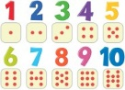  Mathematics  - We will play a track game 1-10 counting forwards and backwards.  - We will do a dot-to-dot to 10.  - We will play a subitizing game with a friend.  - We will find and sort 2D shapes. | Understanding the World    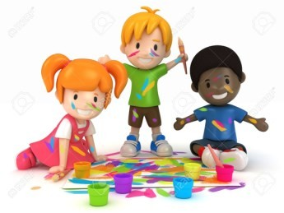  - We will explore ice in the outdoor area.
Physical    - Construction  - Smile for a Mile  - Dough/pen disco  - PE with Ross  - Fine motor activities | Expressive Arts and Design  - We will make a crown (3 Kings)  - We will print stars  - We will make star wands.

