Week Beginning: 15th January 2024
This week in Nursery we will be learning…
Our Nursery Rhyme of the Week is Old McDonald had a Farm.
  Religious Education | - Talking about the losing and finding of Jesus in the temple.
Communication & Language &    Literacy | - Singing Nursery rhymes.  - Activity: Zoo Game—A bus drives around the circle. When it stops at a given child they find an animal beginning with the given letter e.g. p for pig, polar bear, panda, parrot etc.  - Hide and seek—The farm animals are under a blanket. One animal will be taken. Children to make the noise of the animal that they think is missing.  - Can you find—objects will be hidden around the room and children will race each other in pairs to find the objects that has been said using fred talk e.g. can you find a h-a-t.
Mathematics & Physical development   | - Smile for a mile!  - Squiggle while you wriggle!  - Cutting Skills  - MOTD—drawing and naming 2D shapes.  - Number songs e.g. 5 current buns in a bakers shop, 5 little men in a flying saucer etc.  - Finding different ways to show 2.  - PE in the hall.  (reminder PE kits in nursery are only requested on Friday forest school days.)
Other Areas  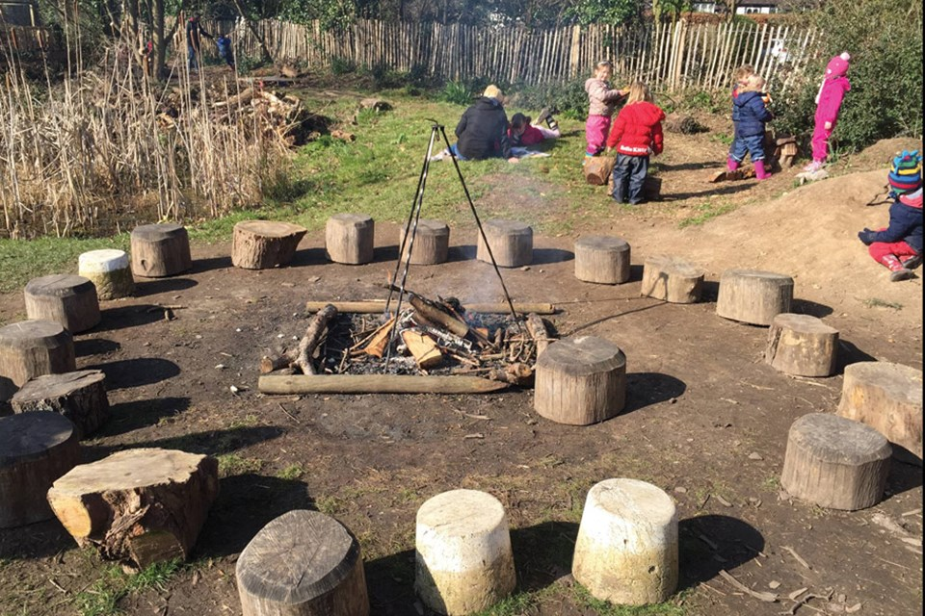 | - Assembly with Mrs Glynn.  - Music on Wednesday.  - Talking about different occupations from our nursery rhymes e.g. the farmer, bus driver, doctor etc.  - Forest school on Tuesday and Friday (spare clothes needed on Friday only)

