Week Beginning: 25th September 2023
This week in Nursery we will be learning…
  Religious Education | - Looking at the plants that God made.  - Identifying different fruits and vegetables and how they grow.
Communication & Language &    Literacy | - Going on a listening walk to hear environmental sounds.  - Giant battleships! Children to follow their friends directions to make a tower with 4 different colours.  - Find the bear – children will give each other clues as to where the bear is by making their voices loud and quiet.  - Listening to alliteration stories.  - Re-telling the story of the colour monster and talking about our feelings, in particular what we are scared of.
Mathematics & Physical development  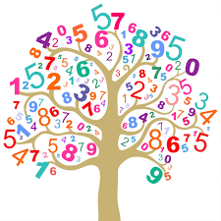 | - Simple number songs to 5.  - Smile for a mile!  - Squiggle while you wriggle!  - Using movement to explore feelings of anger and calm.  - Sorting by colour and size.  - Colour Hunt outside.  - Making a repeated pattern with numicon.
Other Areas  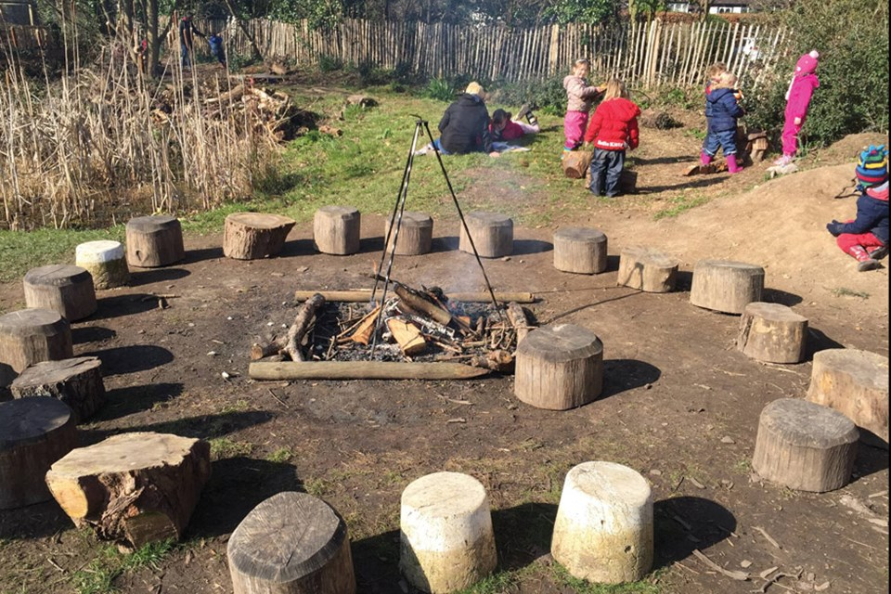 | - Outdoor play.  - Name games to get to know our new friends.  - Circle times about our golden rules.  - Assembly with Mrs Glynn.  - Music with Mrs Marshall.  - Forest School on Friday!

