Week Beginning: 27th November 2023
This week in Nursery we will be learning…
  Religious Education | - Beginning to tell the story of the nativity.  - Singing Away in a Manger.  - PSHE circle time to share our feelings.
Communication & Language &    Literacy | - Activity: Sound blanket- Children hide an object under the blanket. When it is their turn they say what their object is and the initial sound. The item the goes on top for all of the children to practice saying.  - Walk– Listening for environmental sounds.  - Driving game—Children to work on listening skills, stopping when they hear a drum, go backwards when they hear bells, running to the sound of the tambourine.  - What’s in the box?—items hidden in the sound box to orally blend and segment e.g. p-i-g.  - Egg surprises—items inside hollow eggs. Children work in pairs to guess what is inside e.g. rice, a bell, keys etc.  - Tales Toolkit- Independently recording the character, setting, problem and solution of our Gruffalo story.
Mathematics & Physical development   | - Simple number songs to 5.  - Smile for a mile!  - Squiggle while you wriggle!  - Dough disco.  - MathsOfTheDay- capacity. Independently measuring out water in different containers.  - PE in the hall, moving like different beans.  (reminder PE kits in nursery are only requested on Friday forest school days.)
Other Areas  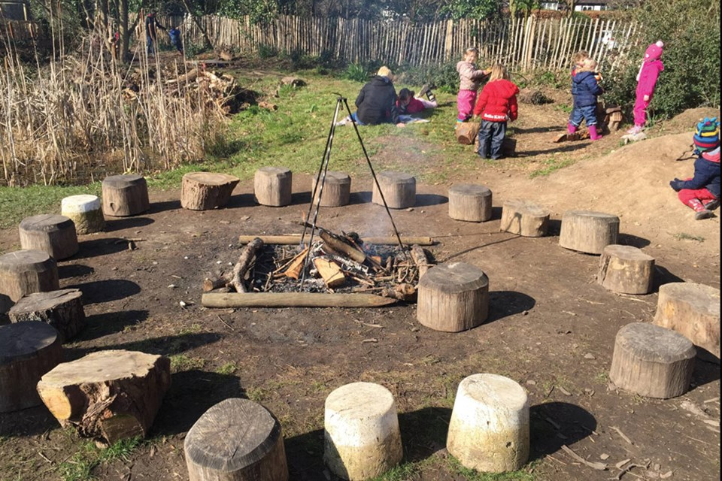 | - Assembly with Mrs Glynn.  - Colour mixing with foam paint!  - Music on Wednesday.  - DT – children will design a home for the Gruffalo, Mouse, Fox, Owl or Snake.  - Forest School on Tuesday and Friday.  (Spare clothes on Friday only)

