Week Beginning: 13th November 2023
This week in Nursery we will be learning…
  Religious Education | - Circle time sharing our family photos.  - Talking about how the angel Gabriel appeared to Mary.  - Circle time to learn about Diwali.
Communication & Language &    Literacy | - What’s in the bag? Children take something out of the bag and think of something that rhymes with their picture.  - Friends for Timmy– Children pick an animal to give to Timmy the turtle. They need to give their animal an alliteration name e.g. percy pig, lilly lion, danny dog etc  - Changing Seats– Children hold an object under a parachute. They swap seats with someone who is holding something beginning with the same sound.  - Metal Mike, blending 3 sounds to make a CVC word to feed to our robot.  - Our magic story box will reveal our story for this half term!
Mathematics & Physical development   | - Simple number songs to 5.  - Smile for a mile!  - Squiggle while you wriggle!  - Dough disco.  - MathsOfTheDay- going on a shape hunt.  - Making Rangoli patterns with 2D shapes.  - PE in the hall, moving like different animals.  (reminder PE kits in nursery are only requested on Friday forest school days. Children are not expected to come into school in a kit for their PE session as all nursery uniform is optional)
Other Areas  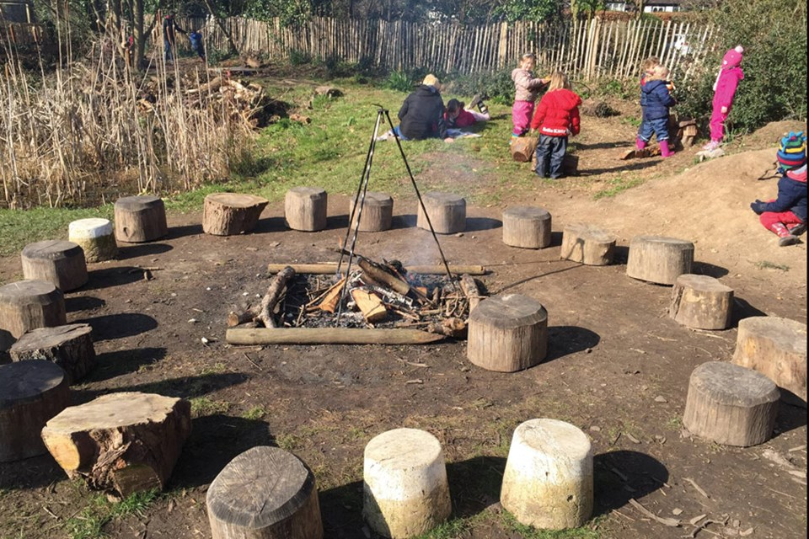 | - Assembly with Mrs Glynn.  - Music on Wednesday.  - Forest school on Tuesday and Friday.  (Spare clothes are not needed on Tuesday)

