Week Beginning: 6th November 2023
This week in Nursery we will be learning…
  Religious Education | - Talking about how all families are different and sharing photos of our own families.  - Talking about our special Nursery family.
Communication & Language &    Literacy | - What’s in the bag? Children to take an object from the magic sound bag and say what it is and what sound it begins with e.g. a spoon, ‘s’ for spoon.  - Making different animal noises.  - Silly soup, making soup with different rhyming words e.g. bear and pear.  - Playing ‘I Spy’ to hear the initial sounds in words.  - Metal Mike, blending 3 sounds to make a CVC word to feed to our robot.  - Exploring our magic story box which has some footprints and a snake in to guess our new story for this half term!
Mathematics & Physical development  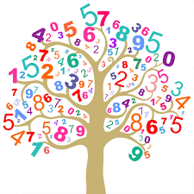 | - Simple number songs to 5.  - Smile for a mile!  - Squiggle while you wriggle!  - Dough disco.  - MathsOfTheDay- find large and small objects outside to compare and order.  - Counting autumn objects, ensuring we can count a small amount of objects accurately.  - PE in the hall, moving like different beans.  (reminder PE kits in nursery are only requested on forest school days. Children are not expected to come into school in a kit for their PE session as all nursery uniform is optional)
Other Areas  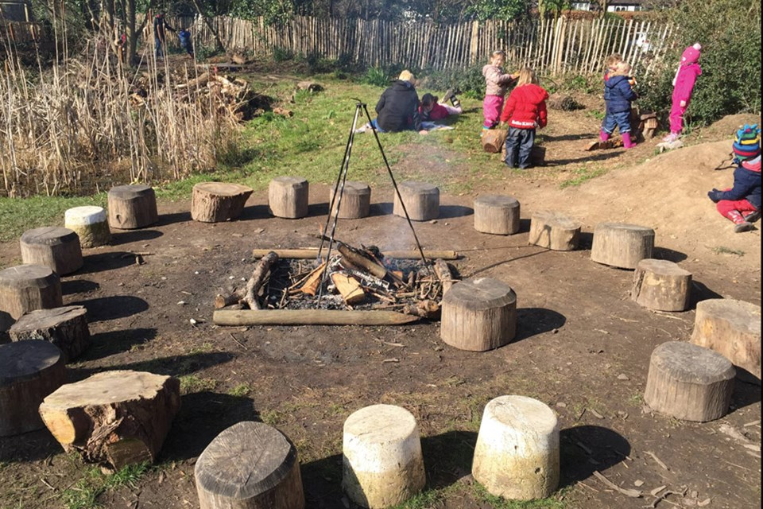 | - Assembly with Mrs Glynn.  - Music on Wednesday.

