Week Beginning: 9th October 2023
This week in Nursery we will be learning…
  Religious Education | - Looking at our similarities and differences.  - Knowing God made us all special and unique.
Communication & Language &    Literacy | - Sound lotto, making sounds with the correct animal.  - Making a band! Explain why we like certain instruments.  - Which sound? Hearing an instrument and knowing which sound it is.  - Hidden instruments, going on an outdoor hunt!  - Shopping bag, listing items we got from the shop, ensuring they all begin with the same sound.
Mathematics & Physical development  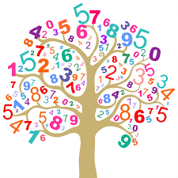 | - Simple number songs to 5.  - Smile for a mile!  - Squiggle while you wriggle!  - Dough disco.  - Using movement to explore feelings.  - Making patterns independently.  - Ordering pumpkins from biggest to smallest.
Other Areas  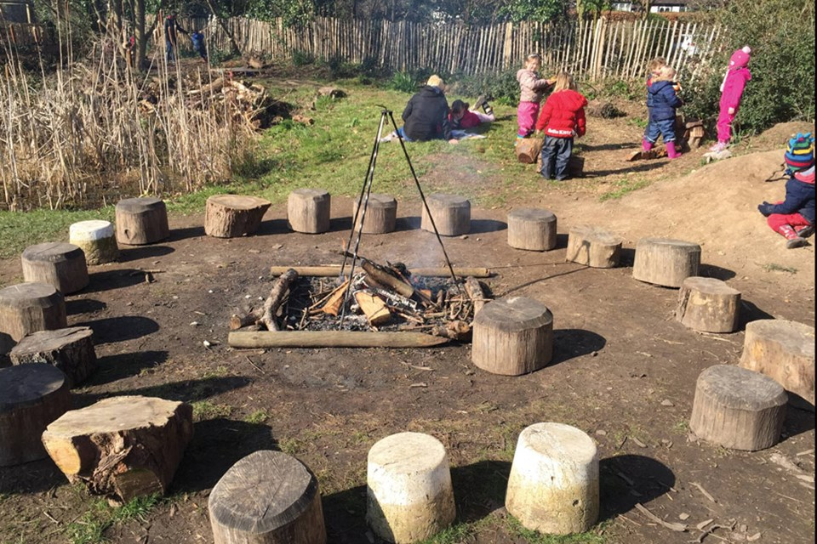 | - Decorating our own colour monster talking about our feelings.  - Assembly with Mrs Glynn.  - Music on Wednesday.  - Forest school on Friday!  - Circle times to learn about Mo Farrah.  - Creating our own painting inspired by Piet Mondrian.

